Infonique

iSEB Door V1.0

|  |  |  |
| --- | --- | --- |
| Prepared by | Date | Version |
| Bing Ran | 24/2/2024 | 1.0 |

# Abstract

This document provides detailed of Infonique iSEB Door specification.

# Document History

|  |  |  |  |
| --- | --- | --- | --- |
| **Date** | **Rev** | **Modifier** | **Changes** |
| **24-Feb-2024** | 1.0 | Bing Ran | First Draft |
|  |  |  |  |
|  |  |  |  |
|  |  |  |  |
|  |  |  |  |

# Contents

Abstract 2

Document History 2

Contents 3

Table of Figures 4

Table of table 4

1 Introduction 5

2 Drone main board 5

2.1 Drone Main Board Pinout 6

2.2 Connectors 7

2.2.1 Power input connector 7

2.2.2 Motor 7

2.2.3 Motor control connectors 8

2.2.4 SD card connector 8

2.2.5 Barometer BME/BMP 280 module 9

2.2.6 Accelerator & gyro sensor MPU6050 module 9

2.2.6 GPS GT-U7 module 10

GT-U7 module able to communicate through UART communication 10

2.2.7 Radio frequency nRF24L01+ 2.4GHz wireless RF transceiver module 10

RF module able to communicate through SPI communication 10

3 Drone controller board 12

3.1 Pinout 12

# Table of Figures

*Figure 1: Top and bottom layer of drone main board* 5

*Figure 2: Battery Connector* 7

*Figure 3: Motor power connectors* 7

*Figure 4: Motor control connectors* 8

*Figure 5: SD card connector & module* 8

*Figure 6: BME/BMP280 connector & module* 9

*Figure 7: MPU6050 connector & module* 9

*Figure 8: GPS GT-U7 connector & module* 10

*Figure 9: RF module connectors & module* 10

Figure 10: Ultrasonic sensor connectos & module 11

*Figure 11: Bluetooth connector & module* 11

# Table of table

Table 1 Expansion board pinout 5

# 1 Introduction

This document will discuss the details of the drone main board, drone controller board, accessories and wiring connections of the Infonique drone.

# 2 Drone main board

Drone main board is designed to control the Infonique drone. The drone main board has to be used with an Arduino Uno or Mega. The features that can be provided by the drone main board are listed below:

* Control the speed of 4 motors.
* Able to measure atmospheric pressure, temperature and humidity.
* Able to measure the vibration or acceleration of motion of a structure.
* Able to harness the principle of conservation of angular momentum.
* Able to measure the voltage of the battery.
* Able to communicate with radio frequency devices at 2.4 GHz ISM band.
* Able to communicate with Bluetooth devices.
* Able to measure distance with an object.
* Able to do data logging.

However, some of the features that might not work as expected when using Arduino UNO, such as Bluetooth and distance measuring, are due to the limitations of Arduino UNO. The figure below shows the top and back of the Drone main board. It is 13cm x 13cm .

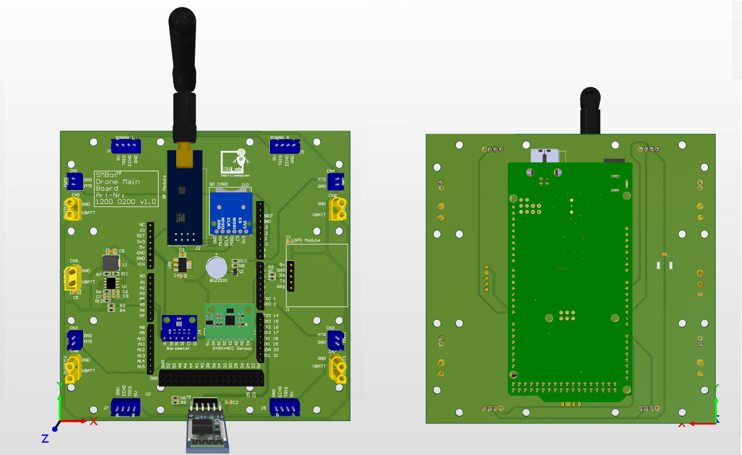*Figure 1: Top and bottom layer of drone main board*

## 2.1 Drone Main Board Pinout

|  |  |  |  |
| --- | --- | --- | --- |
| Pin | Function | Pin | Function |
| D0 | UART Rx | D13 | SPI Clock |
| D1 | UART Tx | D14 | Bluetooth Tx |
| D2 | SD card chip select | D15 | Bluetooth Rx |
| D3 | Motor3 PWM | A0 | Radio frequency chip enable |
| D4 | GPS Tx | A1 | Radio frequency interrupt request |
| D5 | Motor2 PWM | A2 | Ultrasonic Trigger |
| D6 | Motor4 PWM | A3 | ADC Battery |
| D7 | GPS Rx | A4 | I2C SDA |
| D8 | Buzzer | A5 | I2C SCL |
| D9 | Motor1 PWM | A6 | Ultrasonic Echo1 |
| D10 | Radio frequency chip select not | A7 | Ultrasonic Echo2 |
| D11 | SPI MOSI | A8 | Ultrasonic Echo3 |
| D12 | SPI MISO | A9 | Ultrasonic Echo4 |

Table 1 Expansion board pinout

*Pinouts that weren't mentioned are not in use.

## 2.2 Connectors

### 2.2.1 Power input connector

* Drone main board provide connector for battery.
* The input voltage limit is 2-3S lipo battery ( maximum 12.6v ).
* There are positive and negative sign on the connector.
* The board will be damaged if connected wrongly.
* The part number of the connector is XT30UPB-M.

### 2.2.2 Motor

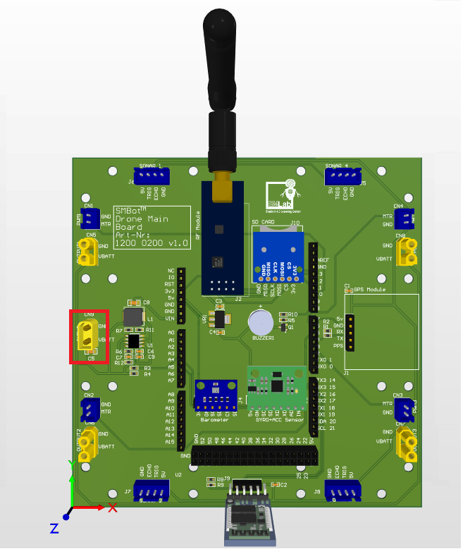*Figure 2: Battery Connector*

* Drone main board provides motor power connectors.
* The voltage is based on the battery input .
* Motor controller will damaged if connect wrongly.
* The part number of the connector is XT30UPB-F.

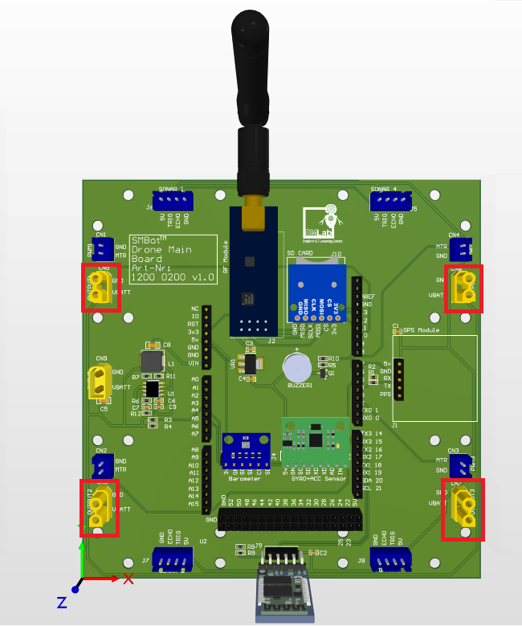*Figure 3: Motor power connectors*

### 2.2.3 Motor control connectors

* Drone main board provides 4 motor control connectors.
* It allows users to control 4 BLDC motors speed simultaneously with motor controllers through PWM.
* Part number of the motor is JST B2B-XH-A.
* The pwm frequency have to be 50hz and the speed will depend on duty cycle.
* The minimum speed is at 5% duty cycle and maximum speed is at 10% duty cycle.

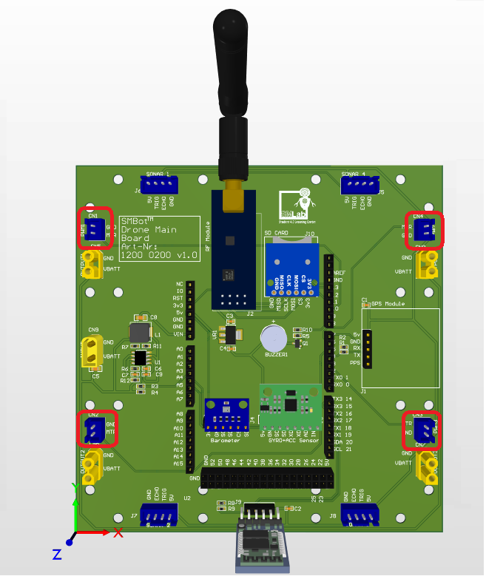*Figure 4: Motor control connectors*

### 2.2.4 SD card connector

* Drone main board able to communicate with SD card module through SPI communicatoin.
* SD card module able to store data.

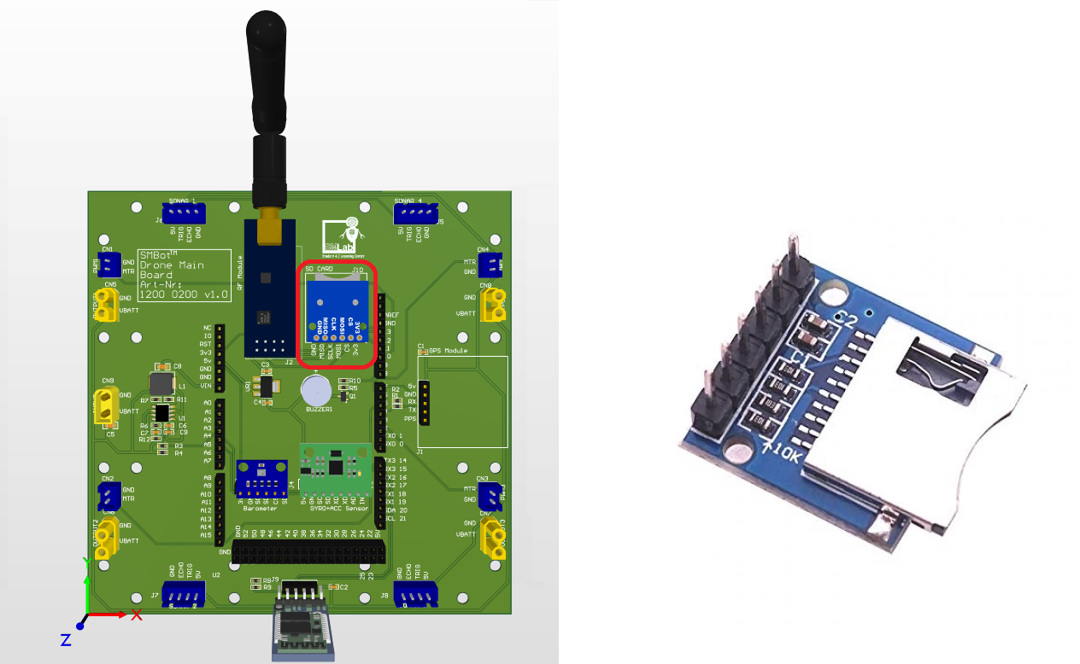*Figure 5: SD card connector & module*

### 2.2.5 Barometer BME/BMP 280 module

* BME/BMP280 module able to communicate through I2C communication
* The power supply to BME/BMP 280 is 3.3v.
* BME/BMP280 module provide data of atmospheric pressure, temperature and humidity.

### 2.2.6 Accelerator & gyro sensor MPU6050 module

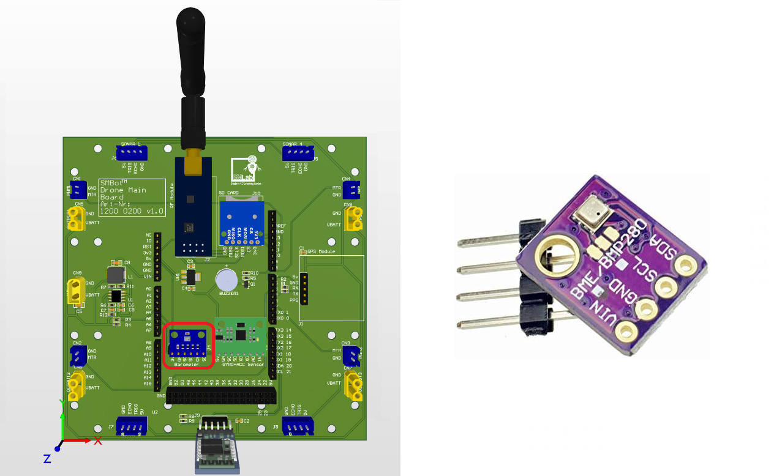*Figure 6: BME/BMP280 connector & module*

* MPU6050 module able to communicate through SPI communication
* MPU6050 module provide data of the vibration or acceleration of motion of a structure.
* MPU6050 module provide data of angular momentum.

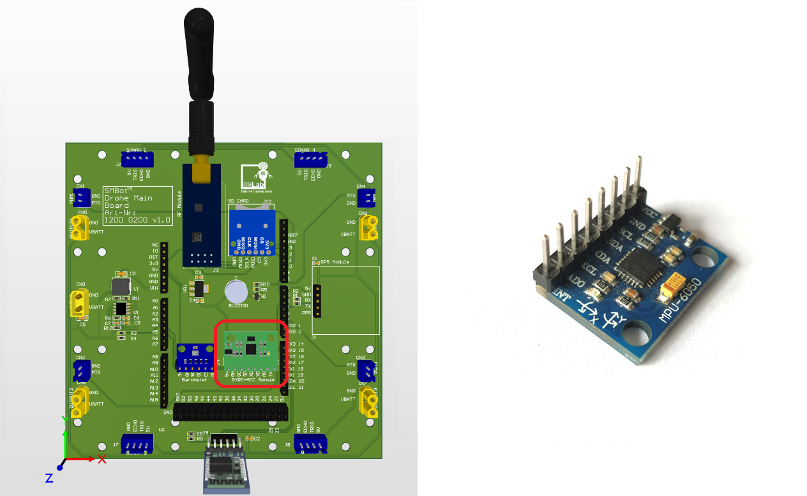*Figure 7: MPU6050 connector & module*

### 2.2.6 GPS GT-U7 module

### GT-U7 module able to communicate through UART communication

* GT-U7 module able to provide gps locationa and also real time clock when there is satelite signal.

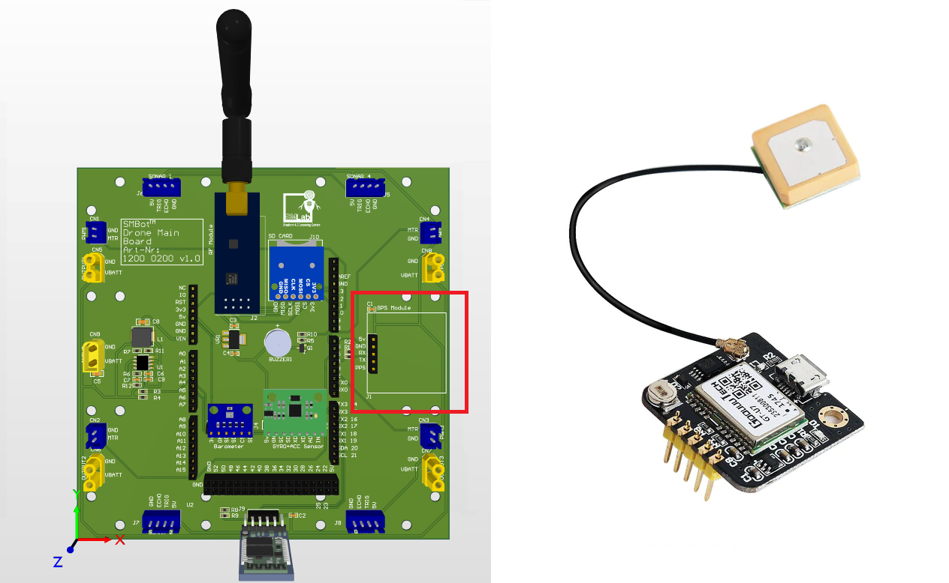*Figure 8: GPS GT-U7 connector & module*

### 2.2.7 Radio frequency nRF24L01+ 2.4GHz wireless RF transceiver module

### RF module able to communicate through SPI communication

* RF module able to communicate with radio frequency devices at 2.4 GHz ISM band.

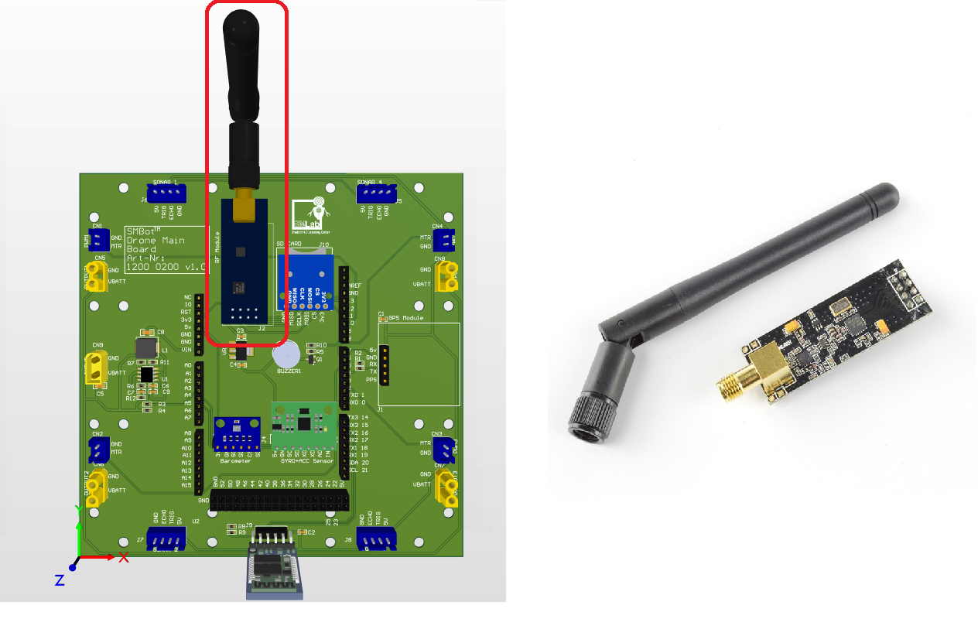*Figure 9: RF module connectors & module*

2.2.8 Ultrasonic sensor HC-SR04 module

* Ultrasonic sensor able to communicate with 2 GPIO pins.
* Only available when using with Arduino Mega.
* Ultrasonic sensor able to measure distance with an object.

2.2.9 Bluetooth module HC-05 module

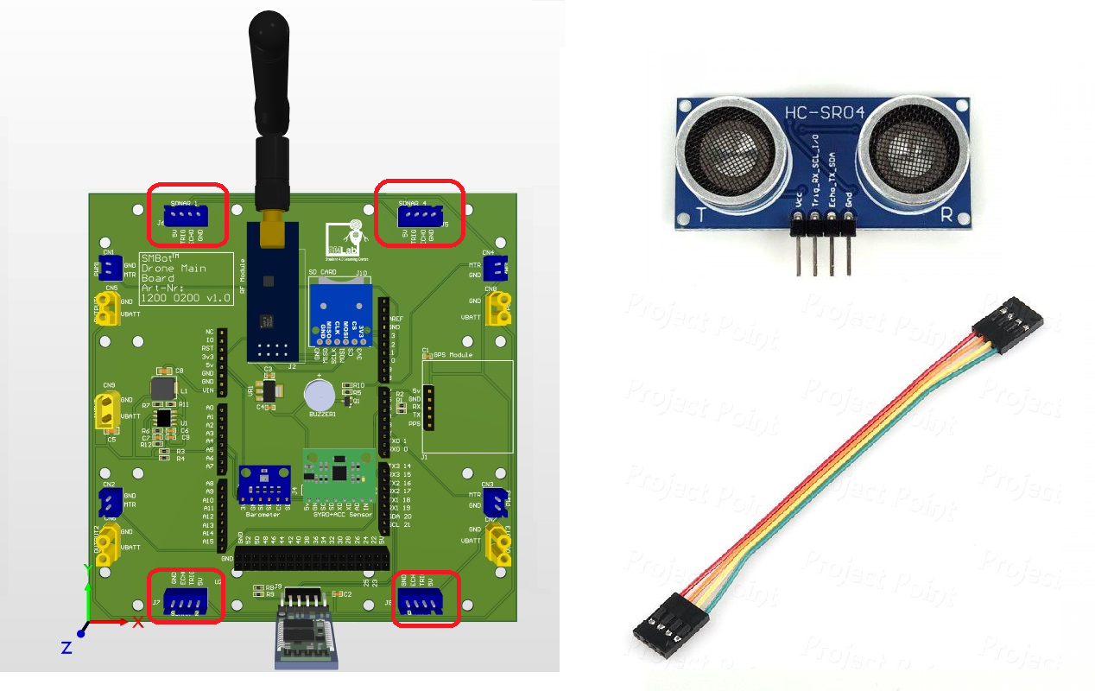*Figure 10: Ultrasonic sensor connectos & module*

* Bluetooth module able to communicate with uart communication.
* Only available when using with Arduino Mega.
* Bluetooth module to communicate with bluetooth devices such as phone.

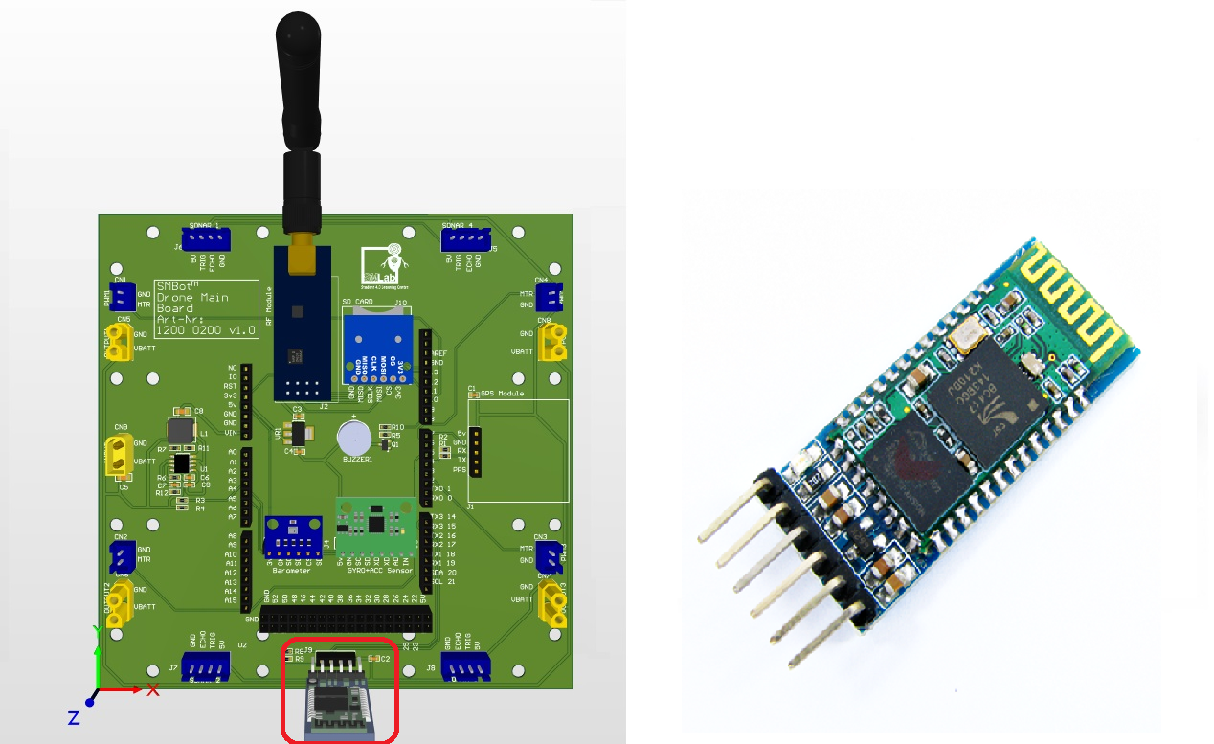*Figure 11: Bluetooth connector & module*

# 3 Drone controller board

Drone control board is designed to communicate with the Infonique drone main board. The drone controller board has to be used with an Arduino Uno. Drone controller able to power by 9v battery. Drone controller board contain the components listed below:

* 2 Joy sticks
* 1.8 inches LCD module
* RF module
* RGB led
* Buzzer

The figure below shows the top and back of the Drone main board. It is 12cm x 8.5cm .

## 3.1 Drone controller pinout

|  |  |  |  |
| --- | --- | --- | --- |
| Pin | Function | Pin | Function |
| D0 | UART Rx | D10 | Radio frequency chip select not |
| D1 | UART Tx | D11 | SPI MOSI |
| D2 | Left Button Input | D12 | SPI MISO |
| D3 | Right Button Input | D13 | SPI Clock |
| D4 | RBG Led | A0 | ADC Right Button Vertical |
| D5 | Radio frequency interrupt request | A1 | ADC Right Button Horizontal |
| D6 | SD card chip select not | A2 | ADC Left Button Vertical |
| D7 | LCD TFT chip select | A3 | ADC Left Button Horizontal |
| D8 | Buzzer | A4 | LCD TFT Reset signal not |
| D9 | Radio frequency chip enable | A5 | LCD TFT Data / Command signal |

Table 2 Expansion board pinout

# 3 Accessories

### SunnySky A2212 980KV Brushless Motors x 4

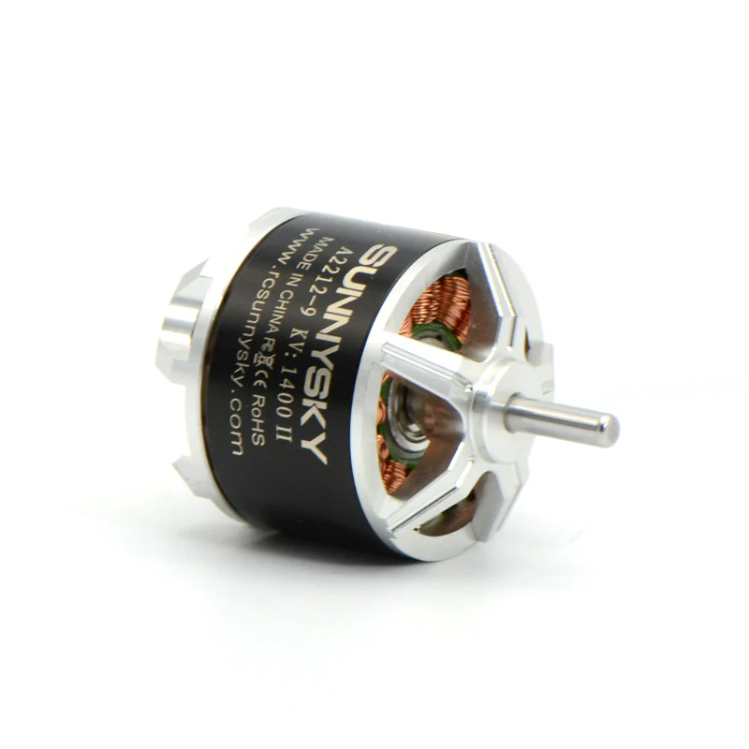

### 9450 Self-Tightening Propeller Set x 2

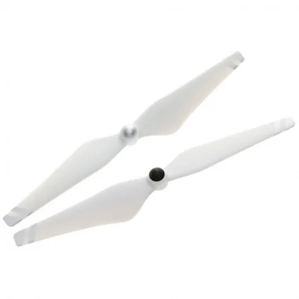s

* Skywalker 20A Motor Controller x 4

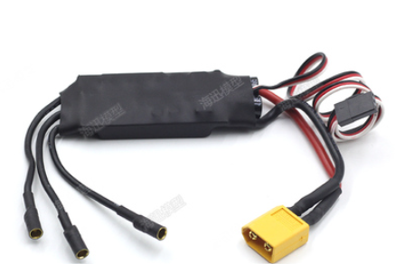

* Motor controller to drone main board signal connector x 4
  + Remove the 3P 2.54 mm female connector
  + Joint black wire to black wire , white to red wire & ignore the red color.
  + JST XT 2pin connect with 20cm wire

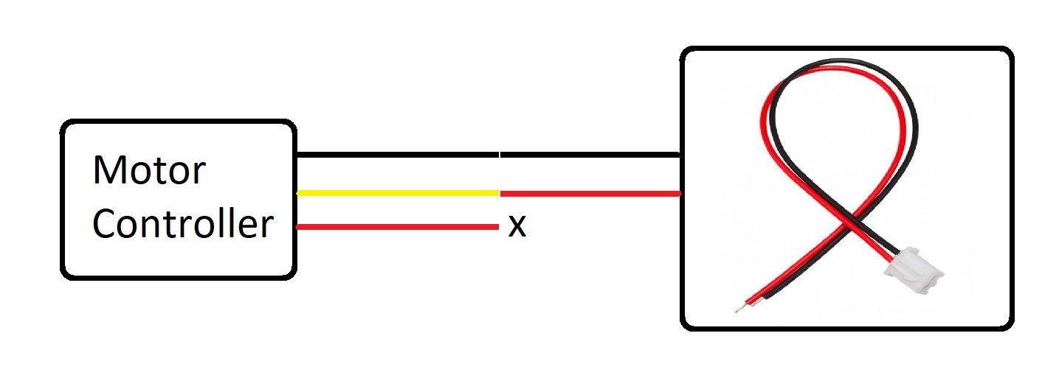

* Motor controller to drone main board power connector x 4
  + 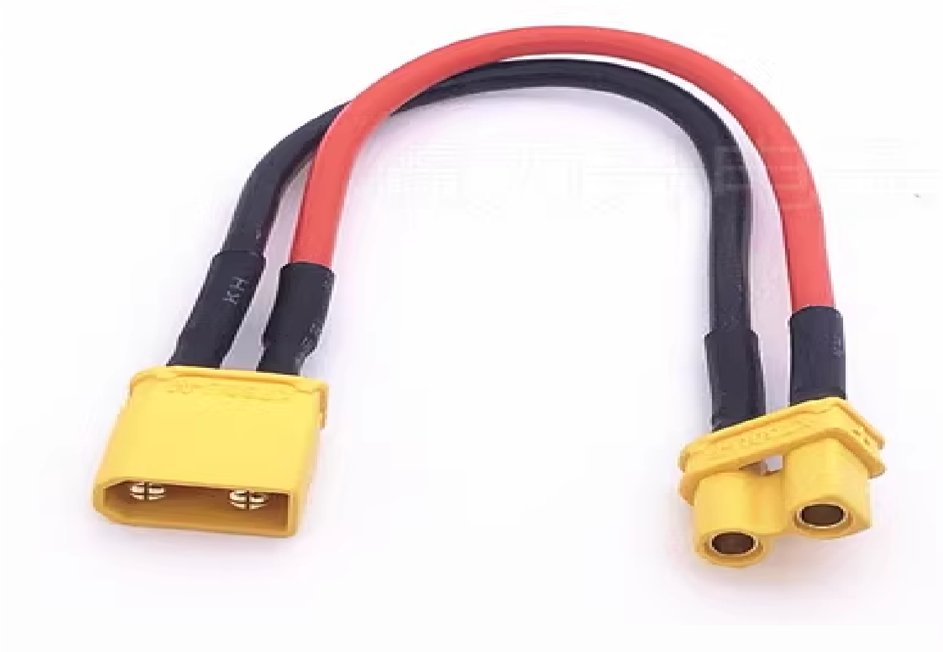10cm XT30 Female to XT30 Male wire extender
* Any 3S Lithium Battery with XT30 female connector x 1
  + The figure below show an 2300mAh 3S lithium battery

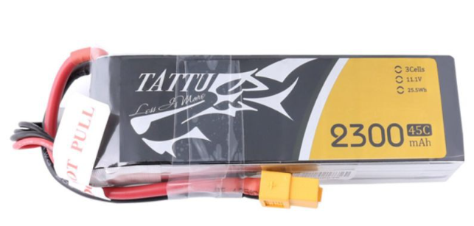

* Cable tie x 8
  + To make sure no dangling wires.

